
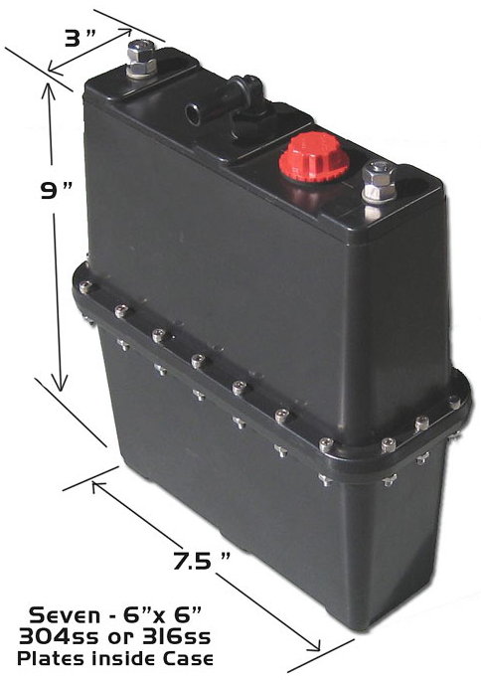

Recommended Booster Installation and Maintenance

Table of Contents

Introduction & Parts List

Installing Components
Mounting: Booster, Flashback Arrester & Relay
Wiring your Kit
Maintenance
Electrolyte Solution
Filling your Booster
What amperage should my booster operate at?
(Frequently Asked Q & A can be found on website)
Progress Report Form
This information is critical for our progress in this technology and is greatly appreciated when reported.
Terms and Conditions
*Warning- Be sure to read all directions and Terms/Conditions before further action.

Language

The B3 is a device that splits water up into hydrogen and oxygen using electricity. There are many names for these kinds of devices that are meant for transportation applications. Here are just a few so while reading the instruction there will be no confusion. Electrolyzer, hydrogen booster, cell, booster, hydrogen generator.

The gas that comes out of the hydrogen generator is hydrogen and oxygen also known as: browns gas, hydroxy, oxyhydrogen, HHO.

Electrolyte is the substance that gets mixed in the distilled water to make it conduct electricity. Only use sodium or potassium hydroxide.

Introduction

Congratulations for purchasing your new hydrogen booster. Get ready to improve fuel economy, cut emissions and gain horse power. We greatly appreciate your willingness to participate in the transformation to clean energy. We will continue to do our best to provide the public with credible information as well as reliable products.
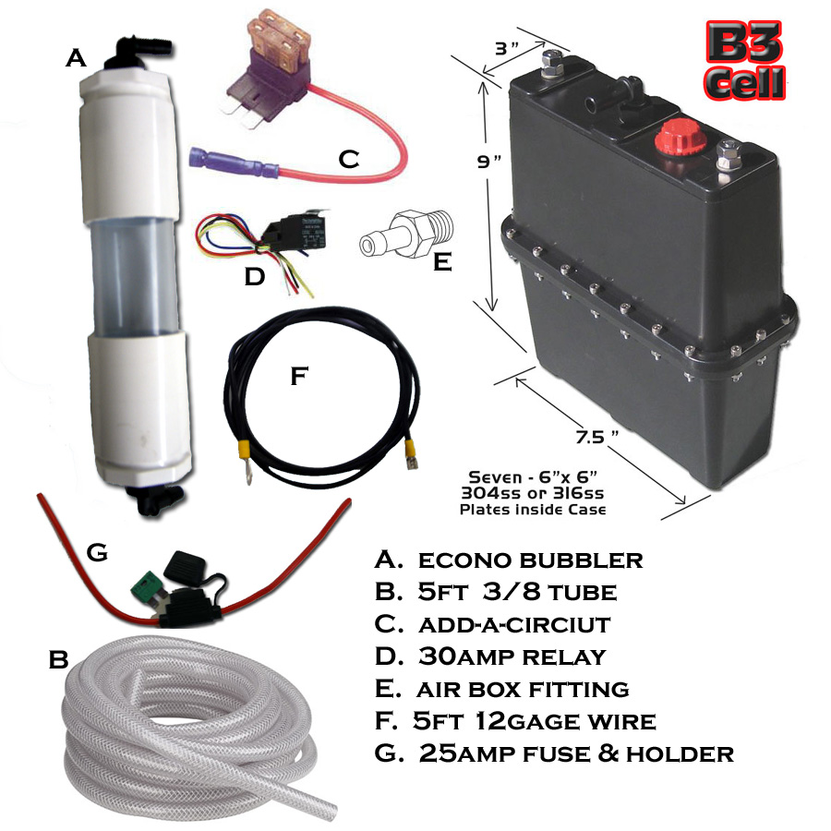
Additional Items:
Reservoir w/pump auto fill circuit PWM Digital amp meter
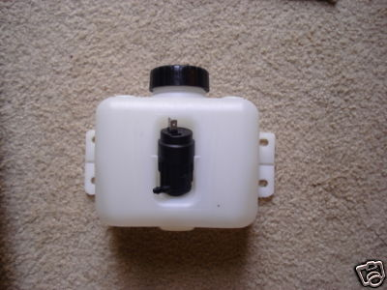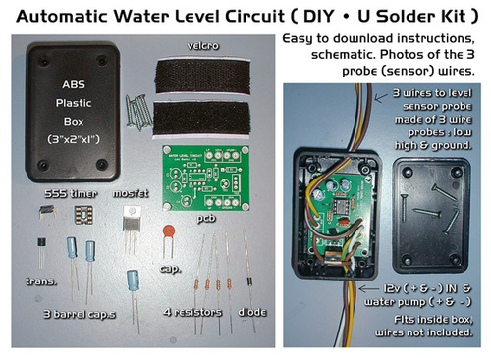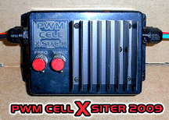

Installing Components

First we will install all of the physical components of your kit; Booster, Flashback Arrester, Relay, Hoses and Fittings. Then we will focus on the diagram to install the wiring components of your kit.

Step 1 Mounting your Booster
First item that needs to be addressed is to be sure that you are installing your booster in a well ventilated and spark free area. Even though your booster is free from any leaks and is in perfect working condition, we want to take every safety precaution possible.
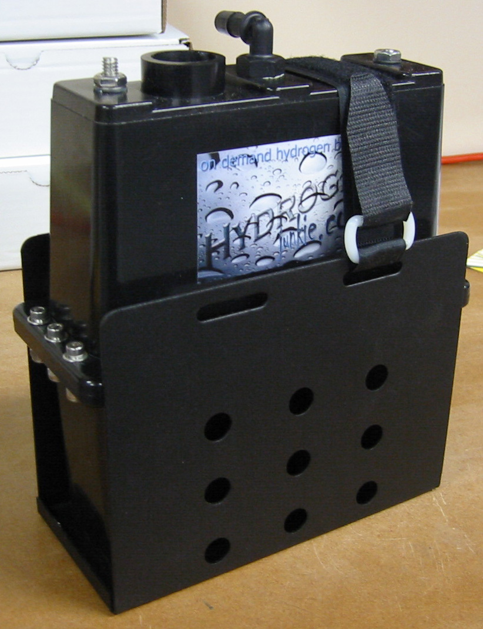
- The preferred area to mount your booster is in front of the vehicles radiator. The reason you want to mount your booster here is for the constant flow of air. The best way to eliminate steam vapor from your booster is to keep it in a well ventilated and cool environment. If you mount the B3 in front of the radiator you will most likely need to use more electrolyte because the cell will stay much cooler.
- Mount your booster to a sturdy bracket preferably to the frame of your vehicle. Be sure that your unit is free from contact with any moving parts and also that it is free from any hot surfaces.
- Be sure that your unit is in the upright position with the fill cap facing upward. Also be sure the cell is in an easily accessible area so that you can easily operate the solution refill portion on your booster.
- Note: Hydrogen Junkie makes a convenient mounting bracket for the B3 shown to your right.

Step 2 Mounting your Bubbler & Flashback Arrester
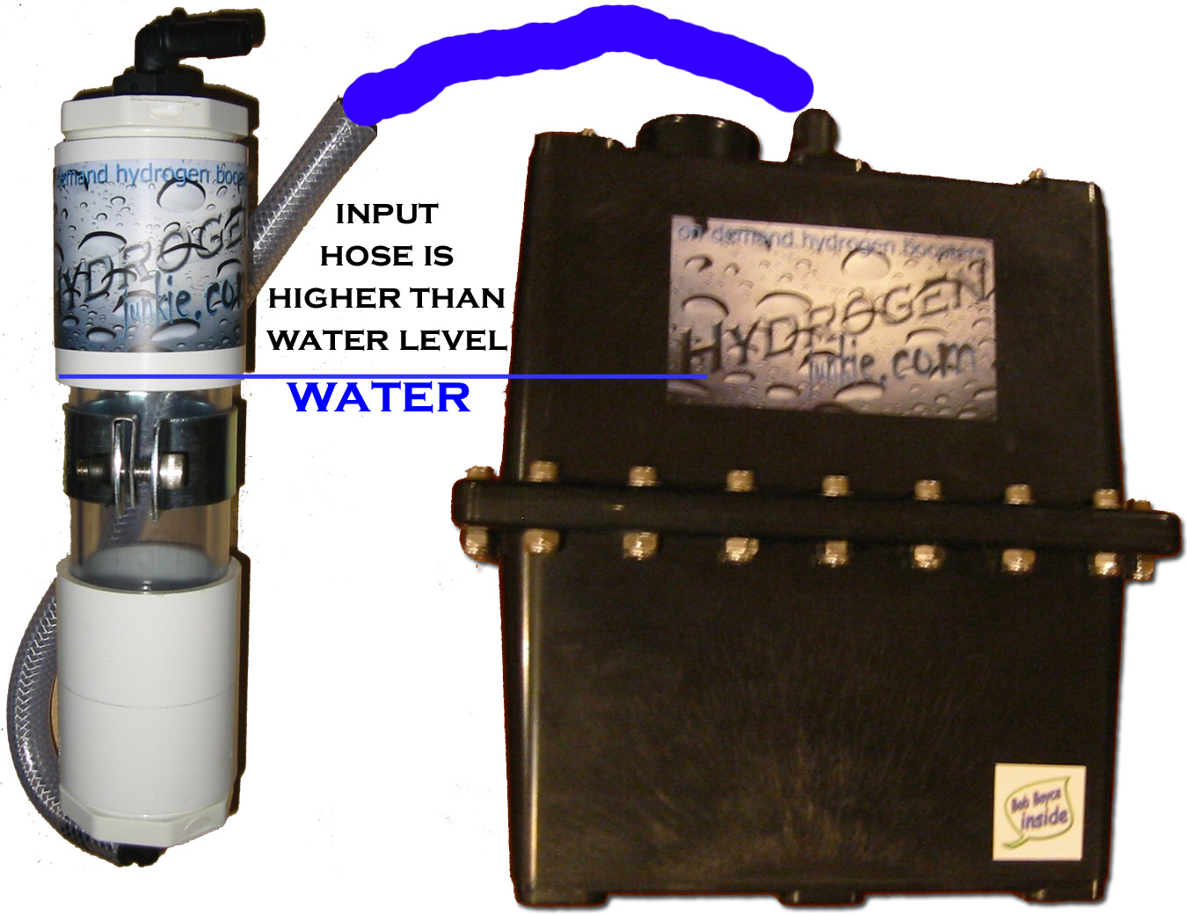
Again, find an area that will be free from any moving parts and hot surfaces. Mount your bubbler/flashback arrester in such a position that allows the hydroxy gas lines to flow freely without any kinks or bends.
- You must make sure that the gas input hose of the bubbler is fastened so it is above the water level of the bubbler. This will allow you to mount the bubbler any hight relitive to the booster and prevent water flowing back into the hydrogen cell.

Step 3 Mounting your Relay
You can mount your relay practically anywhere you want in your engine compartment. Here are a couple of suggested tips to use while you do.
- When mounting your relay make sure that you are mounting to something secure and that will be free from any heavy vibration, this will maximize the life of the relay.
- Be sure that you do not mount your relay to any hot surfaces (if the relay gets too hot it is possible that the internal components will melt and malfunction.)
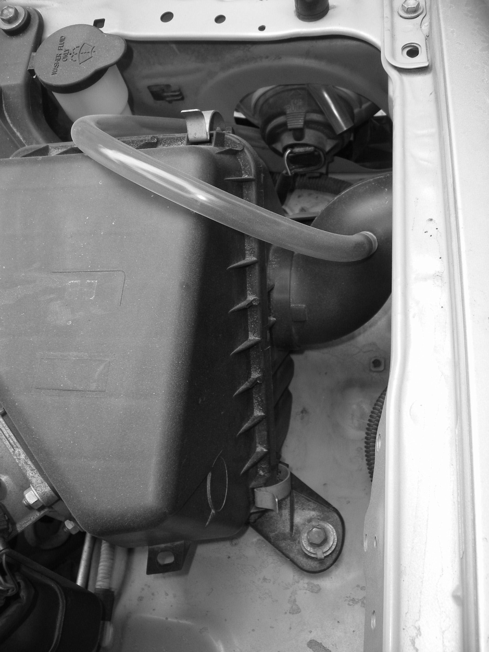
- A great place to mount your relay is close to the booster. This will make the power wires as short as possible, making less resistance.

Step 4 Connecting your fitting and hoses
After you have your booster and bubbler/flashback arrester mounted it is time to install your fitting into your air box. We recommend drilling directly into your air box before your air filter.
- The reason we want to mount the hydroxy gas fitting before your air filter is because we want to protect your engine from any possible contaminants that may be present in the hydroxy gas.

Wiring your Booster
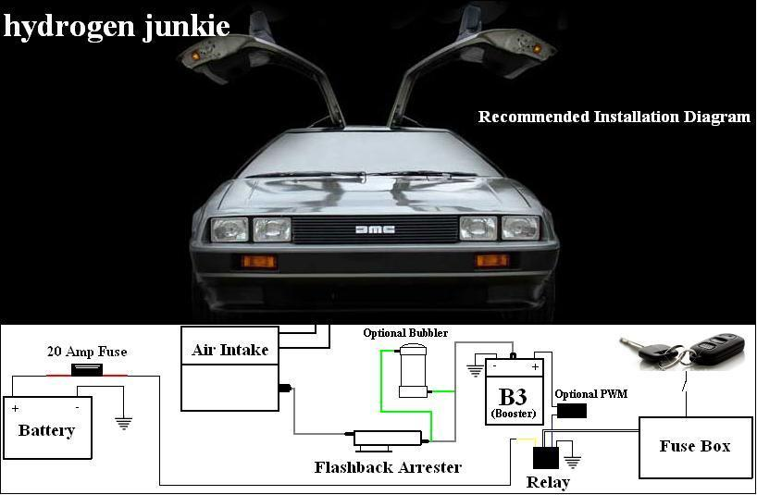

*Written directions will refer to the above diagram.

Step 5 Wiring Diagram
In this section we will be working with the detachable portion of your relay (The female portion of the relay that has the five protruding wires.)
- Detach the female end or your relay so you are only working with the wire portion.
- The only wires that we are going to be working with are the: White, Black, Blue and Yellow. (The red center wire can be discarded.)
- Black Wire- Connect the black wire to a secure ground. (Preferably to a portion of the vehicles frame or battery.)
- Yellow Wire- Connect your 20A fuse inline with the yellow wire to the positive terminal on your vehicles 12v battery or alternator.
*Important- be sure to remove the fuse until the unit is ready to be tested.
- Blue Wire- Connect the blue wire to the positive terminal on the B3. You might need to use a butt connector to connect the blue wire to the black wire with ring terminal on the end that connects to the post on the booster.
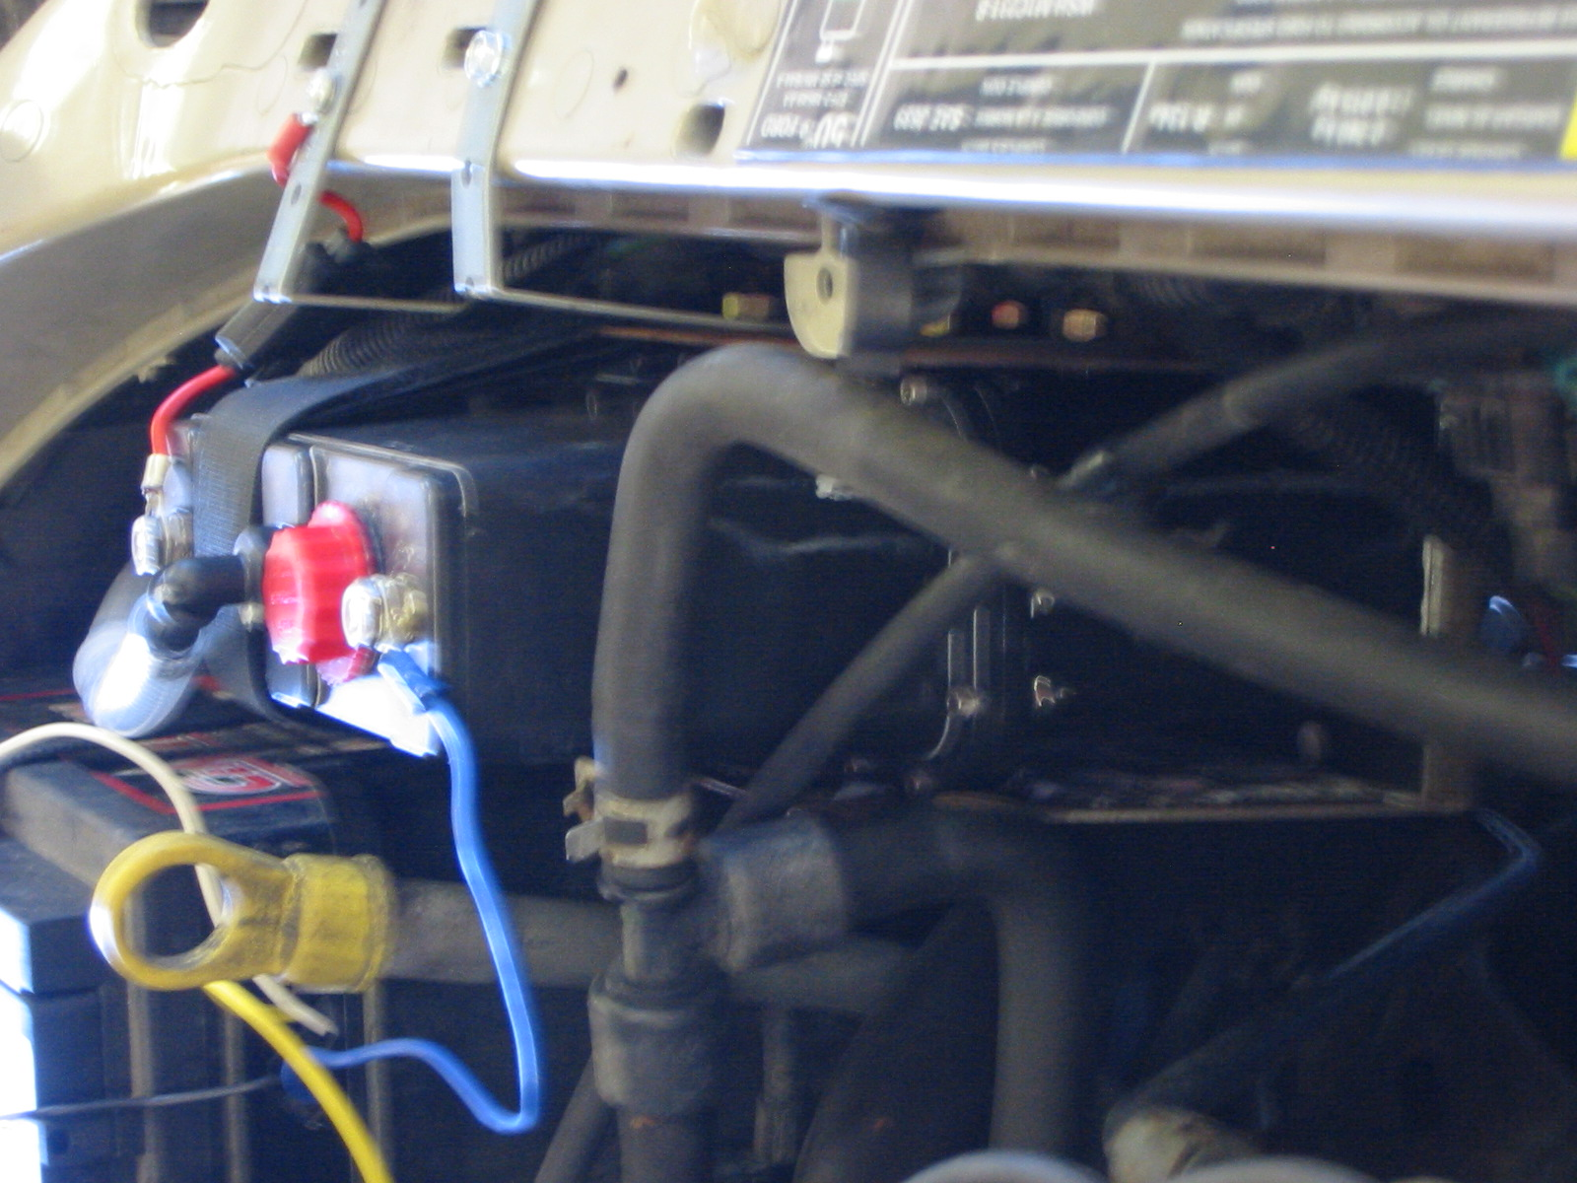
- White Wire- Follow the directions on the “Add-a Fuse” circuit kit. We want to add a fuse to an existing fuse that will be on only when your engine is running. For example, a fuel pump fuse would be a great choice to use because the only time it is signaled to be on is when your engine is running. What we don’t want is for your unit to be on while your engine is off. For example, a stereo fuse would not be a good choice. This is because if the vehicles ignition switch is in the on position, the booster will begin to produce hydroxy gas even though your engine is off. This is not good for 2 reasons. One you will be producing unnecessary hydroxy gas, and two you will be draining your battery.

Step 6 Finishing your B3 Wiring
Next, find a place to connect your B3’s negative terminal to a solid ground. (Preferably to the vehicles frame or battery.)
- Connect the negative terminal from your B3 to a ground source using the wire with the ring terminal on the end. Place the ring on the ground post of the B3.
- Reconnect the female portion of the relay back into the male end.
- Be sure that all wires that have been installed correctly and are securely fastened.
- Also be sure that they are clear from any moving parts and or hot surfaces.
- Lastly reinstall the 20A fuse. (This is the fuse that is inline with the yellow wire and connected to your power supply.)
- Note: If you are installing a PWM start with connecting the input wires. Connect the negative input wire to ground. Connect the positive input wire to the Blue wire from the relay harness. Now connect the positive output wire to the positive side of the hydrogen boost and the negative output to the negative side of booster.

Maintaining your Booster

Electrolyte Solution
When mixing your electrolyte solution we recommend that you always use distilled water. Using distilled water will ensure that booster is free from chemicals and contaminates that may be present in everyday tap/well water.
- Solution Mixture is recommended at 5ml of lye to 800ml of distilled water.
- If your booster is in a location that freezes, you can create a stronger lye to water mixture and give your booster a lower freezing temperature. If you choose to have a stronger solution, you must use a PWM with your unit. This will allow you to control the amount of amperage your unit will pull from your car by the twist of a knob.
- If you are not using a PWM with your kit, you will have to pay closer attention to your lye to water mixture. The amount of lye that you use will determine how many amps your booster will pull. Thus if your solution has a lye content that is too high, your booster will pull more amps than necessary and become less efficient. If your unit is pulling too many amps it has a greater chance of overheating and blowing your fuse.

Filling your Booster
To fill your unit, first remove the fill cap. Insert a funnel into the unit (any kind of funnel should work.) Fill solution just under the top of the plates. Then be sure to re attach fill cap.

- To gain the most efficiency, it is best to keep your solution level right under the top of the plates. If the solution level goes above the plates there will be voltage leakage from the unit’s terminals until the water burns down. When there is voltage leakage, the unit will not produce the most efficient amount of hydroxy gas, generate excess heat and pull more amps until the solution level is down and the electricity passes through all neutral plates.
- Do I need to add solution (lye & water mixture) every time my booster gets low? No! The only time solution needs to be added is when the unit is empty and needs to be filled, or if your booster is not pulling a sufficient amount of current. You can add small amounts of strong solution to your unit until it is pulling the proper amount of amps.

What amperage should my booster operate at?
During our testing at Hydrogen Junkie we have achieved a very efficient 1-1.3 LPM of hydroxy gas at 10amps (max 20amps) with the B3 design once the unit has had sufficient time to be conditioned.

TERMS & CONDITIONS
Viewers and users of this information, linked pages, affiliated pages, files, etc. are granted access to and use of the information contained herein under the following conditions.
Hydrogen Junkie (hydrogenjunkie.com) grants you a limited license to access and make personal use of the contents herein. The information contained herein is intended solely for educational and entertainment uses. For this reason, no advice or information, whether oral or written, you obtain from this website, and/or affiliated and/or linked websites, whether oral or written, shall create any warranty (express or implied) whatsoever. This disclaimer of liability applies to any damages or injury caused by any failure of performance, error, omission, defect in transmission, computer virus, any unauthorized access and unauthorized alteration of the content herein whether for breach of contract, tortuous behavior, negligence, or under any other cause of action. User specifically acknowledges that Hydrogen Junkie (hydrogenjunkie.com) is not liable for the defamatory, offensive or illegal conduct of other users or third parties and the risk of injury of injury from the foregoing rests entirely with the user.
By viewing, using, and visiting this website, user acknowledges that any alteration to a vehicle can result in the breach of various warranties provided by their manufacturers, distributors, or sales dealerships. User acknowledges that he or she shall hold harmless Hydrogen Junkie (hydrogenjunkie.com) its affiliates, sponsors, whether in their own personal capacity or representative capacity through corporations, partnerships, and the like in any event a warranty is thereby nullified. Moreover, user acknowledges that he or she is hereby apprised or does already know the fact that various alterations of their vehicle, no matter how minor or insignificant may not be in compliance with the laws of their particular state, jurisdiction, county, or other Federal law. Hydrogen Junkie (hydrogenjunkie.com) expressly urges all users to refer to all laws to ensure they are in complete and fastidious adherence therewith. Hydrogen Junkie (hydrogenjunkie.com) does not advocate the violation of any laws for any purposes whatsoever. User agrees to use this website contingent upon his or her agreement to abide by all applicable laws.
Furthermore, user is warned that various alterations may be very hazardous especially with respect to the energy systems of the vehicles. Hydrogen Junkie (hydrogenjunkie.com) denies all responsibility for any injuries or damages resulting from alterations to the fuel systems. Due to the dangerous nature of working with the fuel or energy systems of vehicles, Hydrogen Junkie (hydrogenjunkie.com)expressly warns and recommends that any alterations to their vehicles be made by a licensed, certified, and experienced professional. Moreover, any alterations, and experiments promoted in this site is intended for use on private property (ie. not to be used with publicly subsidized and accessible roads) and exclusively for recreational vehicles. In all cases, user acknowledges and expressly takes the risks attendant to the undertaking of any experimentations or alterations to any vehicle due to the contents of this website.
In addition to the terms set forth above neither Hydrogen Junkie (hydrogenjunkie.com) nor its affiliates, whether acting in their personal, representative, or corporate capacity, and their respective officers, directors, employees, agents, attorneys, accountants, consultants, advisors, and partners shall be liable regardless of the cause or duration, for any errors, inaccuracies, omissions, or other defects in, or untimeliness or unauthenticity of, the information contained within this website, its linked pages, sponsors, and affiliates.
All foregoing contents are the sole intellectual property of Hydrogen Junkie. (hydrogenjunkie.com)

Hydrogen Junkie (hydrogengjunkie.com) • California USA

